Name: Date: ee words 1

The long (e) sound is often represented by the letters ee when it comes in the middle of words, like in the words below.

Remember: Say the word aloud, then say each letter aloud as you write it e.g. 'speech, s ... p ... e ... e ... c ... h'

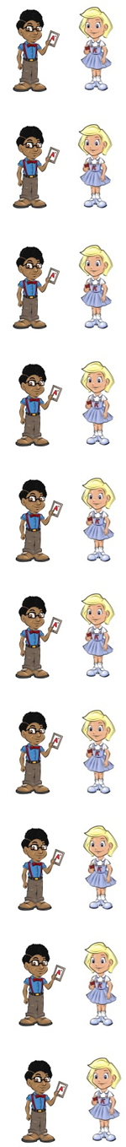
A speech is when someone talks in public.

All animals need to feed.

If you need something, you cannot do without it.

A plant starts off life as a seed.

A weed is a plant that you do not want to grow.

If you cut a part of your body it will bleed.

When you want more and more that is greed.

Each road has a speed limit.

How do you feel today?

Your heel is at the back of your foot.

Now test yourself without looking at the words and check for yourself if you got them all right. Practice writing any words that you made mistakes on again.

© www.SaveTeachersSundays.com 2013
Name: Date: ee words 1

The long (e) sound is often represented by the letters ee when it comes in the middle of words, like in the words below.

Remember: Say the word aloud, then say each letter aloud as you write it e.g. 'speech, s ... p ... e ... e ... c ... h'

Try to spell each word without looking at it.

A is when someone talks in public.

All animals need to .

If you something, you cannot do without it.

A plant starts off life as a .

A is a plant that you do not want to grow.

If you cut a part of your body it will .

When you want more and more that is .

Each road has a limit.

How do you today?

Your is at the back of your foot.

Now check for yourself if you got them all right. Practice writing any words that you made mistakes on again.

© www.SaveTeachersSundays.com 2013

